Demonstration of Proposed Features
1. Landing Interface Overview
The homepage features a dark aesthetic design incorporating card layouts and SVG graphics:

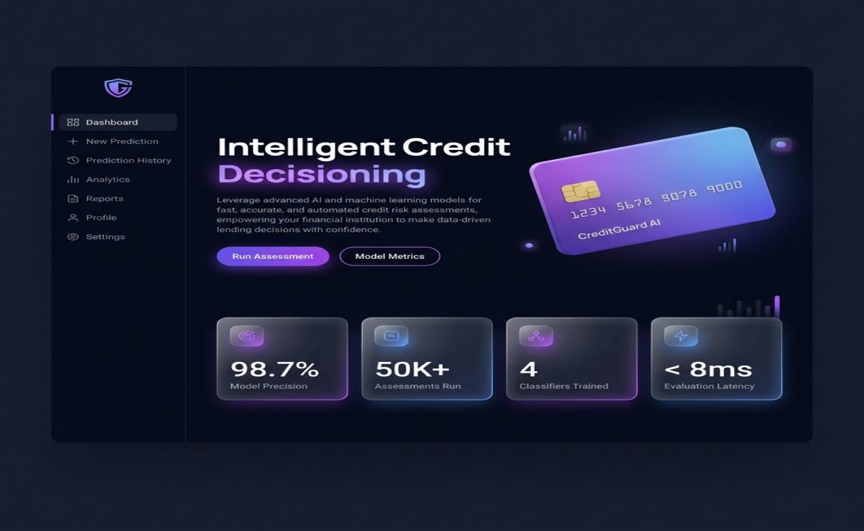
2. Prediction Result Gauges
The scoring wizard computes the final approval outcome and renders it on a custom gauge:

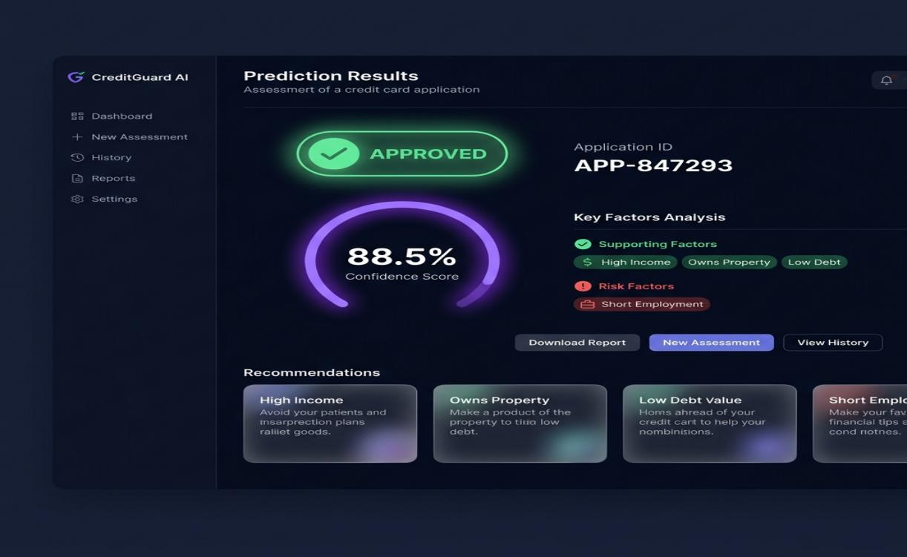
3. Analytics Dashboard Metrics
Risk admins can access active telemetries and metrics inside the console dashboard:

